 Amharic for Adults!

This document tells about Amharic for Adults Software

NOTE: DUE TO SOME LANGUAGE PROBLEM I DID NOT EXPRESSED THE SOFTWARE WELL.

# Brief Introduction

Amharic for adults is a multi-platform desktop software. Designed to make adults learn geez script (aka Amharic script) easily in a very short period of time with interactive and entertaining features.

# Benefit

There are many adults who cannot read Amharic in Ethiopia, many of them want to learn Amharic script but they cannot afford it because of they can't start an elementary or K.G class just to learn Amharic script, because they are on industry or academia. Also some foreigners wishes to learn Amharic script.

For those who wish to learn Amharic, but yet did not started to learn this application is a best solution.

# Features and Functionalities

Amharic for adults have included features needed to teach Amharic scripts in interactive and entertaining way. These are Lessons, Quiz, and A text to speech synthesizer.

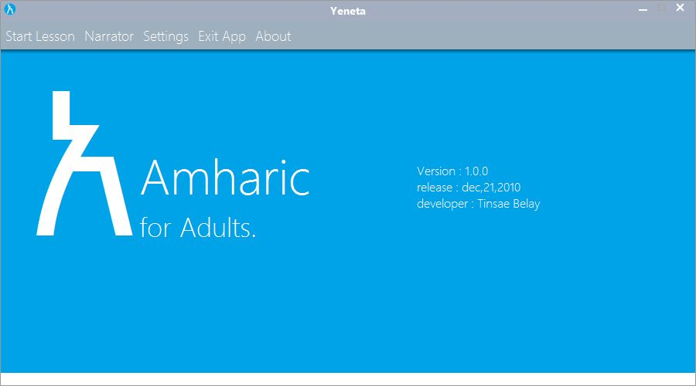

Lesson

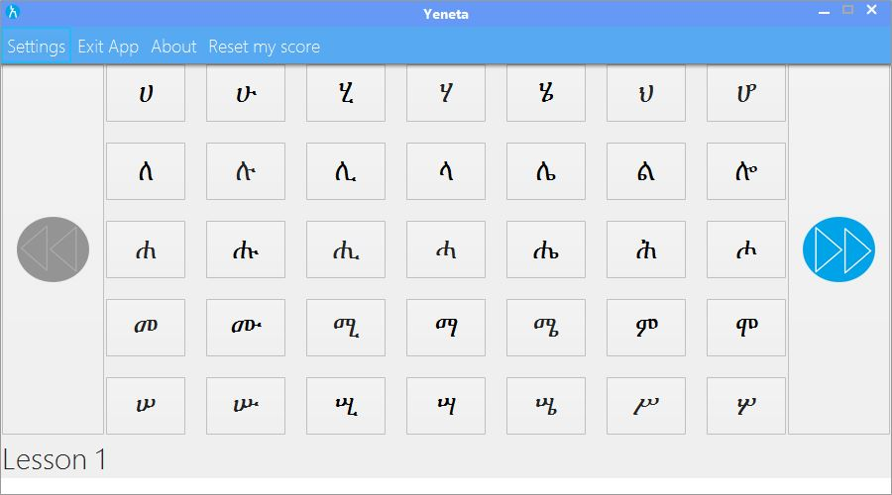

This feature is a main feature of a program where the user learns the fidels by hovering on them. So he can hear a sound and see phonetic code of the Fidel as tooltip. Then the user relates the sound with the Fidel.

The lessons are divided into seven(7), each lesson have 35 fidels(5*7), then a user moves his mouse pointer over a Fidel and hears a sound of that Fidel, also a tooltip appending the phonetic code for the Fidel.

If user wanted to move to next lesson he has to know what he has learned, so can’t just skip to next lesson. The quiz feature takes this responsibility.

# Quiz

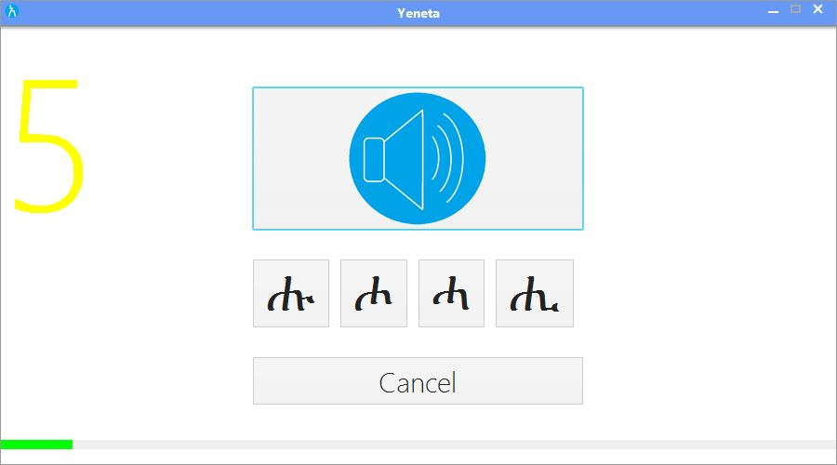

This is a progress assessing tool, a user asses his progress with this feature. A user clicks on a speaker button and a sound will be playback, the user then selects alternative options that matches the sound.

Then the application checks if user is correct or not, if user answer required amount of correct answers (calculated from user configuration) per lesson a user passes to next lesson he can pass the lesson and move to next lesson. Answer should be given on time unless time will out.

# Text to Speech Synthesizer

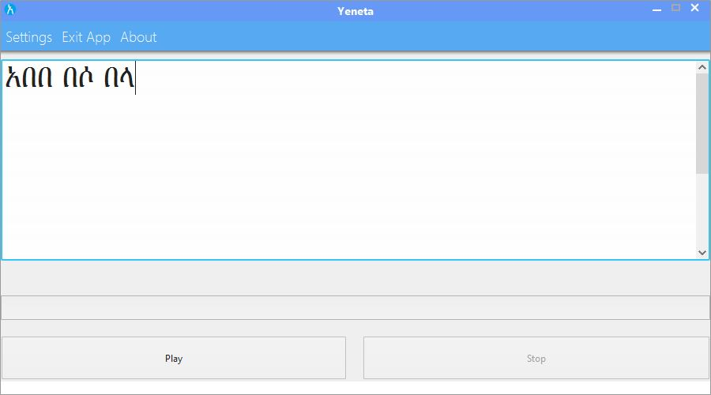

This is another interesting way to learn Amharic scripts. Using this a user type or paste a sentences or paragraph written in Amharic into a text typing area, then start the Text To Speech synthesizer. The Text To Speech synthesizer highlights the Fidel as pronouncing the input text. So the user can learn what sound is produced by what Fidel.

|  |  |
| --- | --- |
|  |  |
|  |  |
|  |  |
|  |  |
|  |  |
|  |  |

USER GUIDE MANUAL

Main Window

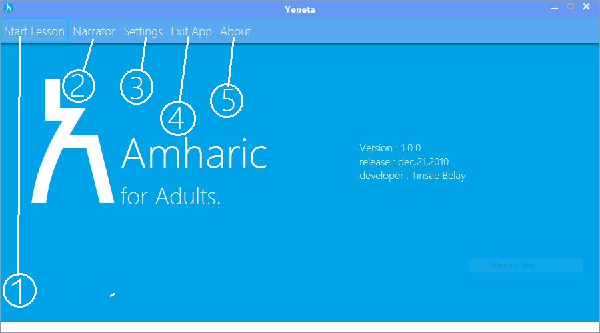

1. This button is used to start a lesson
2. This button is used to start a text to speech synthesizer.
3. This opens a dialog used for configuring user profile.
4. Close the application.
5. Open a dialog that tells about the app.

Lesson

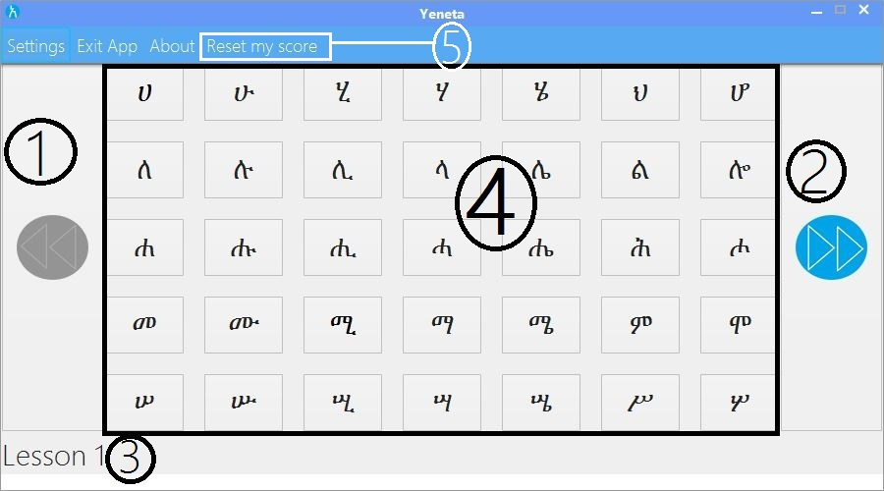

1. Moves the user to next lesson. If a next lesson has not been unlocked it starts a quiz.
2. Moves the user to previous lesson.
3. This label indicates what lesson user is taking.
4. These are Fidels, user studies these. When a mouse hovers over a Fidel the sound of the Fidel is played and phonetic code appears as tooltip.
5. Reset my score button this button resets all user progress, so the user will start from lesson 1, useful when user wanted to retake lesson

Quiz

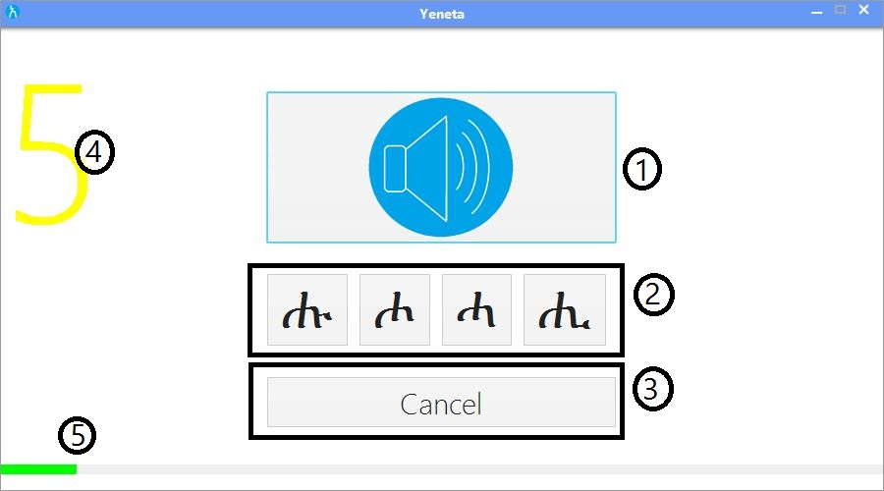

* + - 1. Speaks aloud the question.
      2. Answer options.
      3. Used to cancel the current quiz
      4. Shows remaining time, once time out the quiz will halt
      5. Shows how many percent of quiz has completed.

Narrator

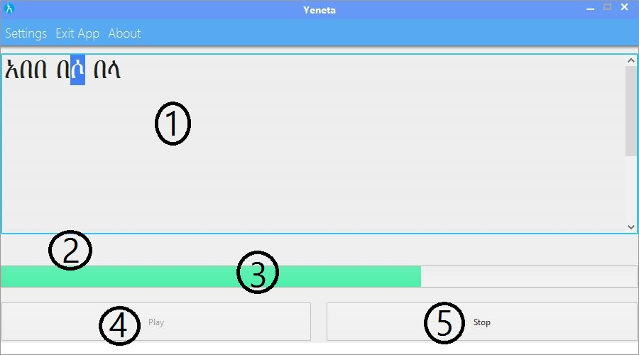

1. User type or pastes here to make it pronounced.
2. This is appeared when our input contains invalid or unsupported input.
3. Shows the percent of pronounced text.
4. Starts a Text To Speech process.
5. Stops Text To Speech process.

# Setting Dialog

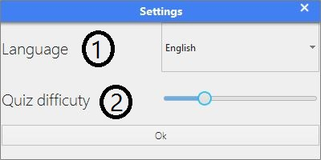

* + - 1. Let the user his preferred display language. Note: currently only English is implemented.
      2. Let the user change the level of hardness of a quiz in turn this affects, timeout and no of wrong answerers per lesson.

# About Dialog

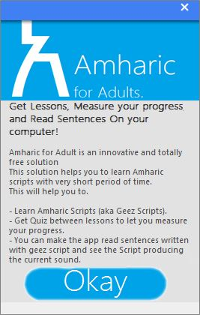

This dialog shows information about the app.

# What makes this app special?

**1.** This app creates quiz questions and answers at runtime or as opposed to hardcoded questions and answers. This produces a random questions and random answer.

**2.** Only one process this app can run per machine at a time. this prevents a lazy users not to get quiz while seeing a lesson from another process

# Conclusion

A person who properly uses this application can definitly learn amharic fidels. Game like quiz makes you love the app.